Module 4: Infrastructure as Code (IaC) – Terraform

Topics Covered:
- Terraform modules and workspaces
- Remote state and state locking
- Terraform Cloud + VCS integration
- Multi-cloud deployments

1. Terraform Modules & Workspaces

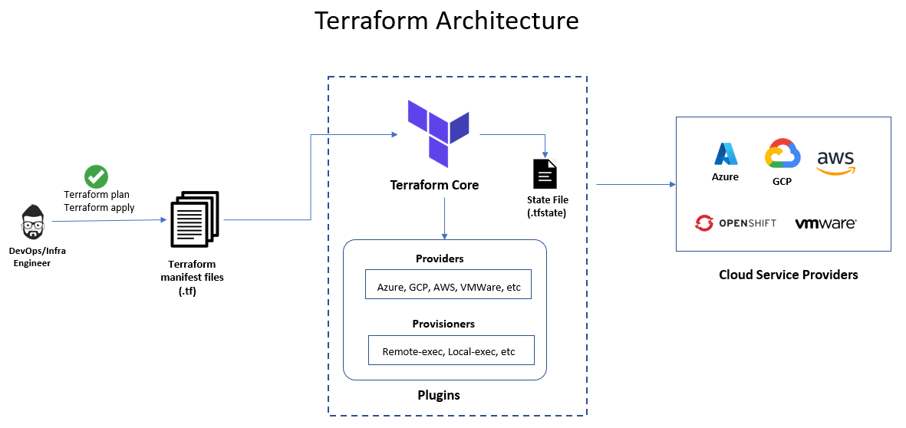
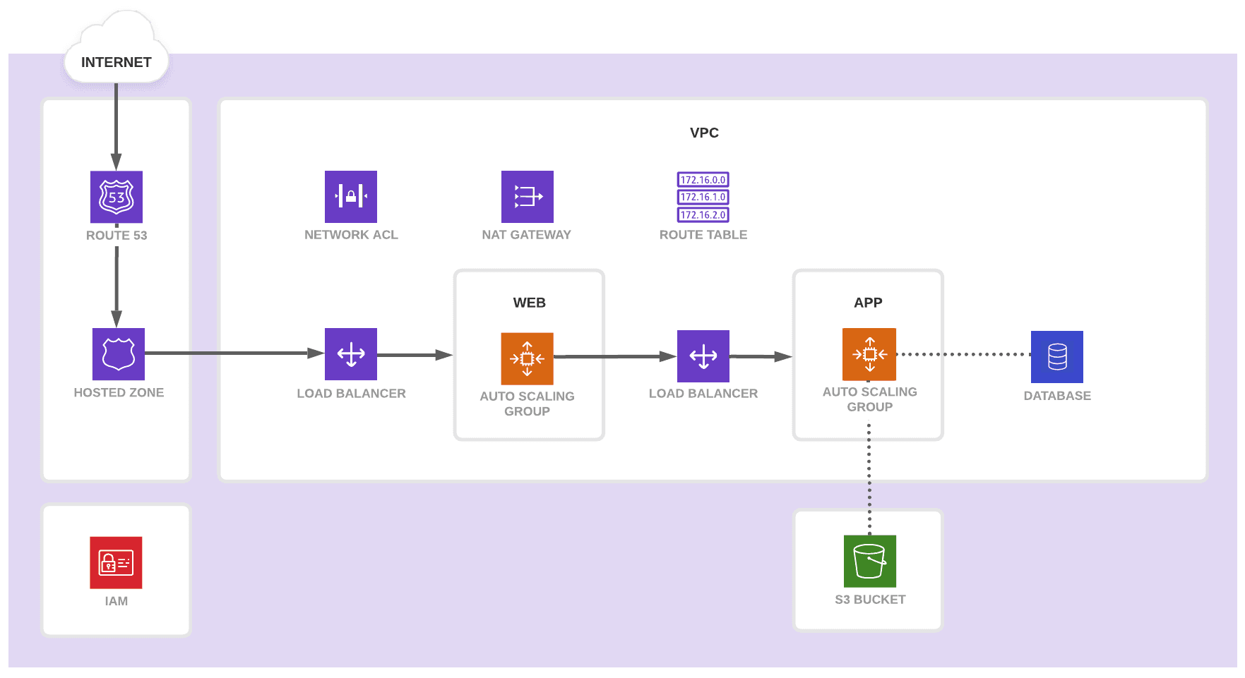

1.1 What Are Terraform Modules?
A module is a group of Terraform configuration files reusable across projects.
Why Modules?
- Reusability
- Standardization
- Cleaner code structure
- Easier testing & versioning
- Strong DevOps automation
Module Structure
modules/
vpc/
main.tf
variables.tf
outputs.tf
ec2/
main.tf
variables.tf
outputs.tf
env/
dev/
prod/
Calling a Module
module "vpc" {
source = "./modules/vpc"
cidr_block = "10.0.0.0/16"
}
Public Module Sources
- Terraform Registry
- GitHub Repository
- Versioned modules:
source = "github.com/vivek/my-vpc-module?ref=v1.0.0"

1.2 Terraform Workspaces
Workspaces allow multiple state files for the same configuration.
Use Cases:
- dev, qa, prod environment switching
- Single module → multiple environments
- Avoid duplicated code
Commands
terraform workspace list
terraform workspace new dev
terraform workspace select prod
How Workspaces Work
Each workspace creates its own state:
terraform.tfstate.d/dev/terraform.tfstate
terraform.tfstate.d/prod/terraform.tfstate

2. Remote State & State Locking
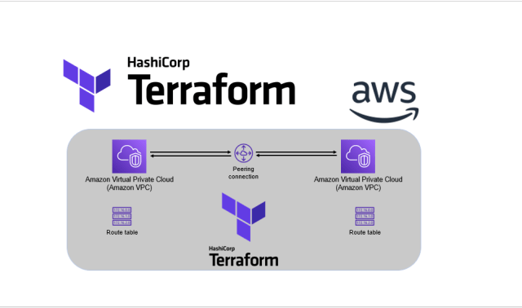
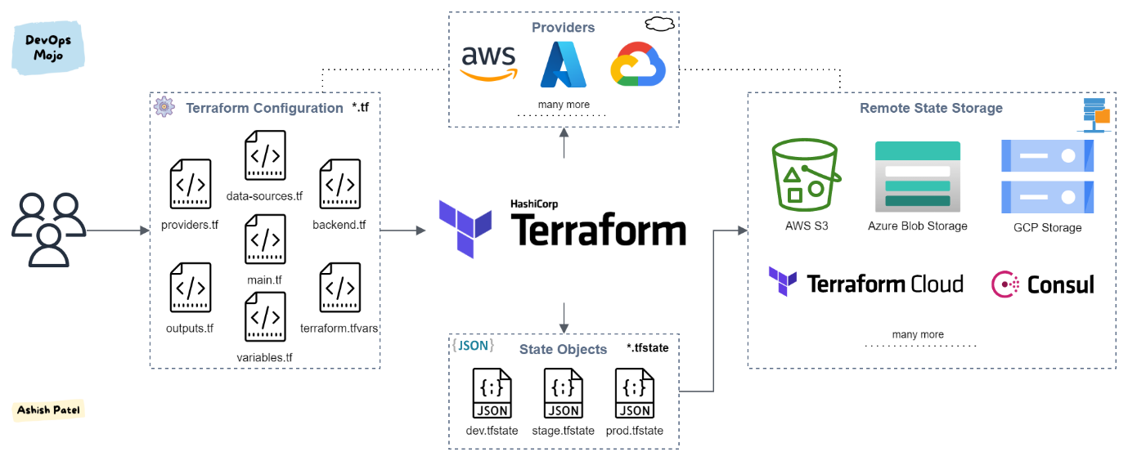


Terraform uses state to keep track of the real infrastructure.
Remote state allows teams to share this state securely.

2.1 Why Remote State?
- Collaboration
- Centralization
- Security
- Automated pipelines
- Prevent state loss

2.2 Backends
Common Terraform backends:
Backend | State Locking | Recommended Use
S3 + DynamoDB | Yes | AWS production setups
Azure Storage | Yes | Azure IaC
Google Cloud Storage | Yes | GCP workloads
Terraform Cloud | Yes | Multi-cloud teams
Consul | Yes | HashiCorp heavy setups

2.3 Example: S3 Remote State + DynamoDB Locking
terraform {
backend "s3" {
bucket = "my-terraform-state"
key = "infra/terraform.tfstate"
region = "us-east-1"
dynamodb_table = "terraform-locks"
encrypt = true
}
}
Benefits:
- Prevents multiple engineers from editing state
- Auto-lock/unlock on apply
- Secure, encrypted, versioned state

2.4 Remote State Data Source
You can consume remote state from other projects:
data "terraform_remote_state" "vpc" {
backend = "s3"
config = {
bucket = "my-terraform-state"
key = "vpc/terraform.tfstate"
region = "us-east-1"
}
}

3. Terraform Cloud & Version Control Integration

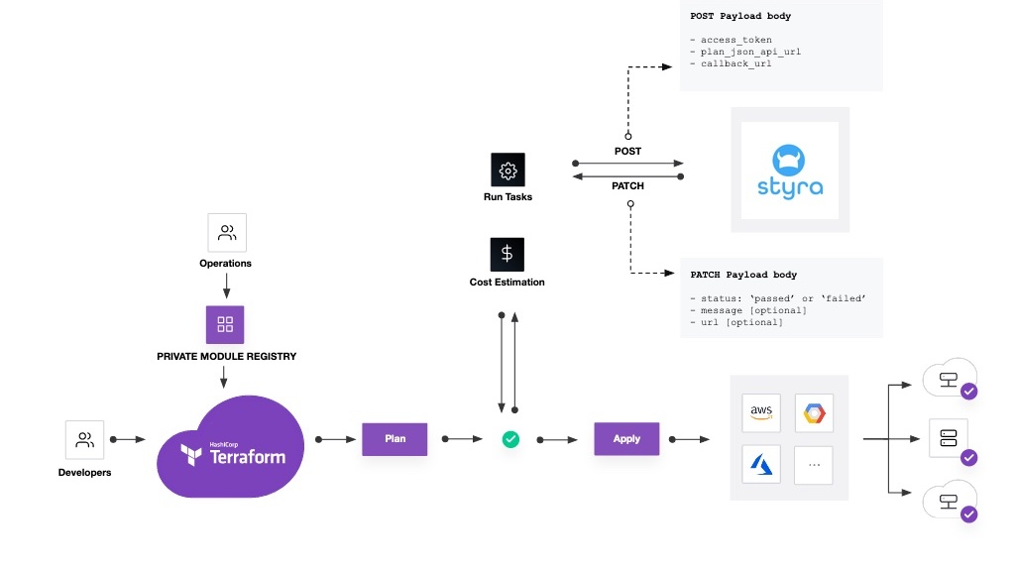
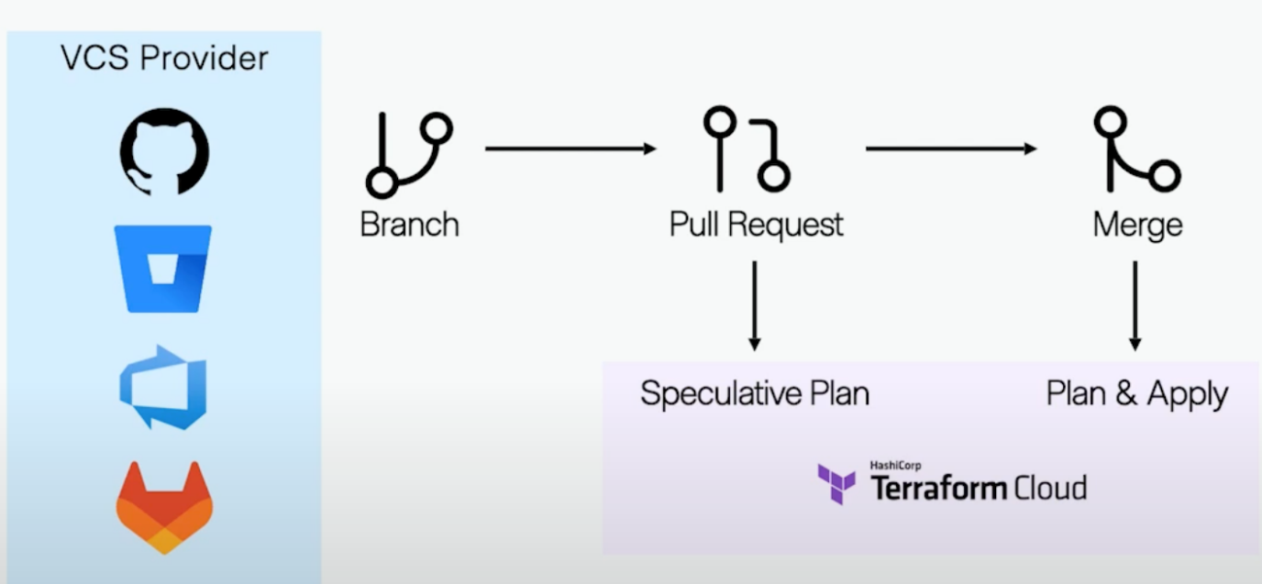

Terraform Cloud (TFC) provides:
- Remote execution
- Version control integration
- Private module registry
- Policy-as-code with Sentinel
- State storage + locking
- Cost estimation

3.1 Connecting Terraform Cloud to GitHub/GitLab/Bitbucket
Steps:
- Create a Terraform Cloud Organization
- Add a Workspace
- Connect VCS (GitHub, GitLab, Azure DevOps, Bitbucket)
- Select the repository
- Each git push triggers:
  - Plan
  - Cost analysis
  - Apply (manual or auto)

3.2 TFC Workspace Modes
Mode | Description
UI/VCS | Run triggered by Git
API-driven | Used from pipelines
CLI-driven | Local CLI with remote state

3.3 Example .terraformrc for Terraform Cloud
credentials "app.terraform.io" {
token = "your_tfc_token_here"
}

3.4 Private Module Registry
Allows teams to publish internal modules.
module "eks" {
source = "app.terraform.io/company/eks/aws"
version = "1.2.0"
}

4. Deploying Multi-Cloud Environments
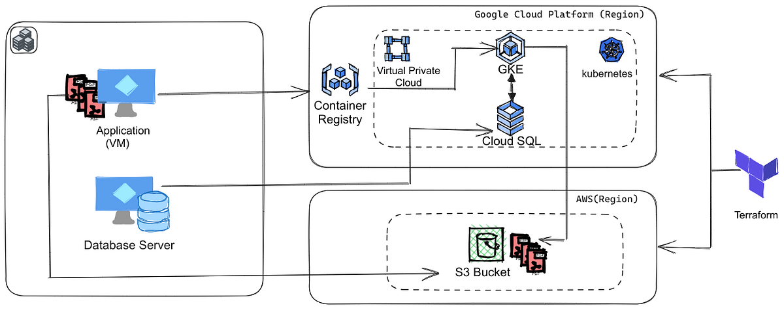
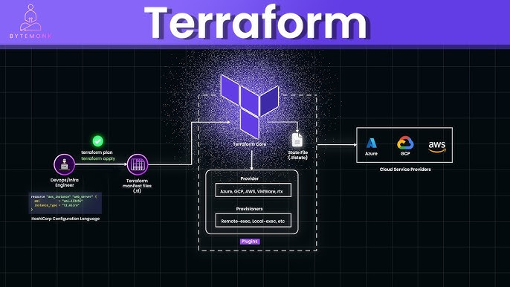
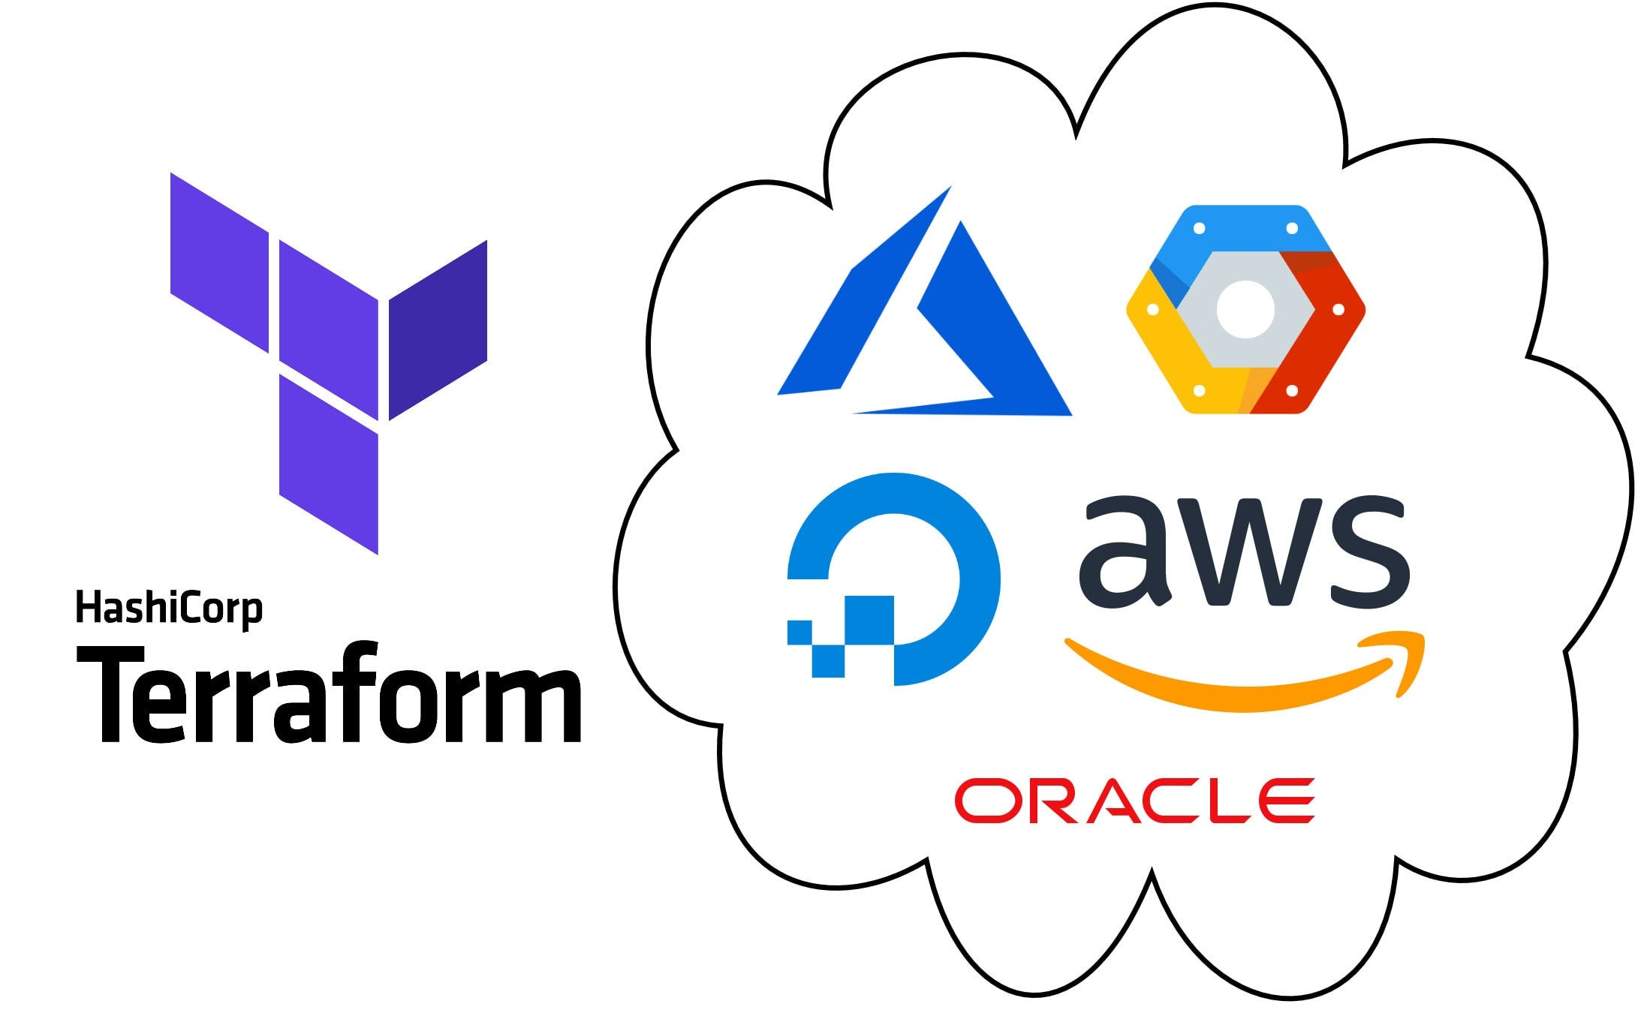
6

Terraform is cloud-agnostic, supporting:
- AWS
- Azure
- GCP
- VMware
- Kubernetes
- OCI
- OpenStack
- Alibaba Cloud
- Multi-cloud federated systems

4.1 Example Multi-Cloud Project Structure
multi-cloud/
aws/
main.tf
azure/
main.tf
gcp/
main.tf
modules/
compute/
networking/

4.2 Example: Create AWS EC2 + Azure VM
AWS: EC2 Instance
provider "aws" {
region = "us-east-1"
}

resource "aws_instance" "web" {
ami = "ami-123456"
instance_type = "t2.micro"
}
Azure: VM
provider "azurerm" {
features {}
}

resource "azurerm_resource_group" "rg" {
name = "prod-rg"
location = "eastus"
}

4.3 Multi-Cloud Use Cases
Use Case | Why Multi-Cloud?
DR & BCP | Backup on another cloud
Hybrid workloads | Only some services needed from each cloud
Vendor lock-in prevention | Avoid dependency on single provider
Geo-redundancy | Better global performance

4.4 Multi-Cloud Best Practices
✔ Use modules to standardize across clouds
✔ Maintain separate state files per cloud
✔ Enforce policies using Open Policy Agent or Sentinel
✔ Use CI/CD pipelines for automation
✔ Ensure strong tagging strategy
✔ Use GitOps + Terraform Cloud for drift detection

Final Summary — Module 4
Topic | Key Takeaways
Modules & Workspaces | Reusable code + isolated environments
Remote State | Central storage with locking & collaboration
Terraform Cloud | VCS integration, remote runs, policies, registry
Multi-Cloud Deployment | Build AWS, Azure, GCP infra in one workflow

